Sheet #6: Manipulating the DOM and using Event Listeners

The html File has been provided for you on Lea.
To Do List:
Using the toDoList.html file (found on Lea), create a to-do list (see sample below). You will add functionality to this web page that displays a to-do list. Use the text entered in the box as the list item and add it to the list when “+” button is clicked ( use DOM MANIPULATION). You will also incorporate a check box before the text of each list item. Make sure the “Clear” button removes all the items from list (use innerHTML).
Use Event Listeners to perform the operations. Do not use HTML Event Handlers or DOM Event Handlers in your code.
Create functions as required.

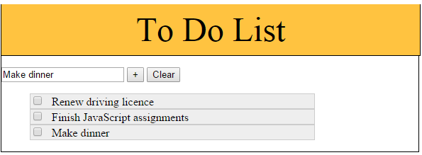

Create an external script for each of this exercises. Use JavaScript code in the external file only, there should be no scripting inside the HTML files.

Files have been provided for you on Lea. Do not make any changes to the HTML files, except to add references to your external script file.

Dynamic Navigation: (exercise derived and modified from Ballard/Moncur text)
Using the Spain file (found on Lea), create a navigation area for the page (see sample below) to allow viewers to jump directly to the information they are looking for.

Create a menu at the top of the screen based on the sub-headings found in the content of the page. Use the title of the headings as the text of the menu items. To test the menu either add more content or make the window smaller.

Add a “return to top” feature to allow the viewer to return to the menu from any location on the page.

